Diploma Computer Engineering Sem. VI

Timetable Generator

------------------------------------------------------------------------------

Developed and Designed by

Adit Bhatia

Hardik Garva

Shivani Hadiya

Under Guidance of

Ms. Honey Gurnani

**

**Tolani Foundation Gandhidham Polytechnic**

**Adipur ( Kutch )**

**CERTIFICATE**

Year :- 2019-2020 Semester :- $5^{th}$

Subject : Project-I

This is certify that **Mr.Adit Bhatia , Mr.Hardik Garva , Ms. Shivani Hadiya** having Enrollment No. 176530307001 , 176530307016 ,176530307017 has completed UDP Project work having title Timetable Generator. All the functionalities required by user with deep analysis and latest techniques.

|  |  |  |  |  |
| --- | --- | --- | --- | --- |
| |  | | --- | |  | | 3:52 PM (9 minutes ago) |  | https://mail.google.com/mail/u/0/images/cleardot.gif  https://mail.google.com/mail/u/0/images/cleardot.gif |
| |  | | --- | | Date of Submission: .  Internal External H.O.D  Examiner Examiner  https://mail.google.com/mail/u/0/images/cleardot.gif | | |  | |

*ACKNOWLEDGEMENT*

I would like to thank to our guide of this project, Ms.Honey Gurnani For the valuable guidance and advice. He inspired us greatly to work in this project. His willingness to motivate us contributed tremendously to our project. We also would like to thank him for showing us some example that related to the topic of the project.

Besides, we would like to thank the authority of TFGP for providing us with a good environment and facilities to complete this project. **Finally, an honorable mention goes to our friends for their understanding and supports on us in completing this project. Without the above, we would have faced many difficulties doing this help of the particulars mentioned project**

DEVELOPED AND DESIGNED

BY

……………………………………………………………………………………..

Student : Adit Bhatia ( 176530307001)

Hardik Garva ( 176530307016)

Shivani Hadiya ( 176530307017)

Guide Name : Ms. Honey Gurnani

Submitted : Head , Computer Department.

Affiliated : TFGP Tolani Foundation Gandhidham

Polytechnic Adipur ( Kutch ).

**Date of Submission : __/__/____**

INDEX

**Name Page No.**

**1.Introduction…………………………………………6**

* Project Summary

1.1 Introduction

1.2 Purpose

1.3 Features

1.4 Technology Stack

**2.Project Management..………………………………9**

2.1 Project Planning

**3.System Analysis…..………………………………....12**

3.1 System Architecture

3.2 Zero level

3.3 ER Daigram

**4.System Design…….………………………………....16**

**5.Screen Layout…….………………………………....22**

**6.Conclusion and Limitation………………………....29**

6.1 Conclusion

6.2 Limitations

6.3 Future Scope

**Chapter : 1**

**INTRODUCTION**

***PROJECT SUMMARY***

**Abstract: *Most colleges have number of different courses and each course has a number of subjects. Now there are limited faculties, each faculty teaching more than one subjects. So now the time table needed to schedule the faculty at provided time slots in such ways that their timings do not overlap and the time table schedule makes best use of all faculty subject demands. We use genetic Velidations for this purpose. In our Timetable Generation We used an Slot Where User can fill all details and Preview The timetable and can change it.***

# 1. 1 Introduction :

Time table scheduling has been in human requirements since all thought of managing time effectively. It is widely used in schools, college and other fields of teaching and working like crash courses, coaching center, training programs etc. In early days, time table scheduling was done manually with one single person or some group involved in task of scheduling it with their hands, which takes a lot of effort and time.While scheduling even the smallest constraints can take a lot of time and the cases are even more worse when the number of constraints or the amount of data to deal with increases. In such cases perfectly designed time table is reused for the whole generation without any changes, proving to be dull in such situations. Other cases thatcause problem is when the number of employers/workers are weak, resulting in the rescheduling of time table or they need to fill on empty seats urgently. They need to schedule their course to meet the need of current duration and facilities that are available to them. However, their schedule should meet the requirements of the new course additions and newly enrolled students to fresh batches. This may result in rescheduling the entire time table once again for its entire batches and to be scheduled in shortest possible time before the batch courses start. Another problem that occur when scheduling time table for exams. When multiple batches have their exam on same day, they need to be schedules effectively taking into account all problems related to the facilities that are available to conduct these exams simultaneously.

* 1. **Purpose :**
* The Purpose of this Timetable Generator is to make work easy.
* In this Windows – Application we have added the Functionalities as per the Requirements.
* The Work which was done **Manually** can be now done **Digitally.** 
  1. **Features :**
* The Login Form for the Security Purpose.
* The Main Form.
* The Different forms for Data Entery of Department , Faculty, Subjects , Lab, Rooms etc.

**1.4 Technology Stack:**

**In Context Tools & Technology**

Front End VB.Net 2019

Database Design Microsoft SQL Server

Management 2019

Design and Components VB.Net 2019

**Chapter : 2**

**PROJECT MANAGEMENT**

**2.1 Project Planning:**

The road to the successful Windows Application Development is the well-planned strategy for the best and optimal use of resources available Project management begins with a set of activities that are collectively called project planning The project planning in done in a way to get the maximum utilization of resources and on time completion of the project Project planning is concerned with identifying and measuring the activities, milestones and deliverables produced by a project

In system the first step in project planning in which we decided the title of our project Timetable Geneartor System is the name of Windows-Application.

In project planning we decided the admin module which module will be design fist and then we think about other forms.

Project planning consists of the following essential activities

* Estimating some basic attributes of the project
* Duration: How long will it take to complete the development? Effort: How much effort would be required?
* The effectiveness of the subsequent planning activities is based on the accuracy of these estimations.
* Scheduling manpower and other resources.
* Staff organization and staffing plans.
* Risk identification, analysis, and planning.

**1.Project Organization :**

This describes the way in which the development team is organized the people involved and their roles in team.

**2. Risk Analysis :**

This describes possible project risks like likelihood of those risks arising and the risk reduction stratifies, which are proposed. The significant risk in our website development is requirement error and omissions. Therefore, cost of fixing the requirement errors at later stages in process can be very high. Experiments have shown that SDLC reduces number of problems associated with the requirement specification. Furthermore, the overall development cost may be lower if a SDLC is developed.

The risk of our system is that it will successfully run. All the Forms where perform the task in correct way, and for users it will attractive to the users so that they will easily use the Application.

**3. Hardware and Web-Application Requirements:**

Hardware Requirement

C2D Processor 4 GB RAM 4 GB free Space HDD drive

**Processor C2D Processor**

**Ram 4GB**

**HDD 4GB Free Space**

**Chapter : 3**

**SYSTEM ANALYSIS**

**3.1System Architecture:**

Insert Details info

database

Logout

Generate Time

table

Add Room

& lab no

Enter Semester

Login Page

(id & Password)

Add Faculty

details

Add Subjects

Details

Add Department

**Use Case:-**

Admin

**3.3ER DAIGRAM:**

**Sub_master**

**Room no**

**Slot_Master**

**Lab_Master**

**Faculty_Master**

**Department**

**Master**

**Login_Master**

**Sem_Master**

**Batch_Master**

**Chapter : 4**

**SYSTEM DESIGN**

**4.1Data Dictionary :**

**Login :- login details comes in its table.**

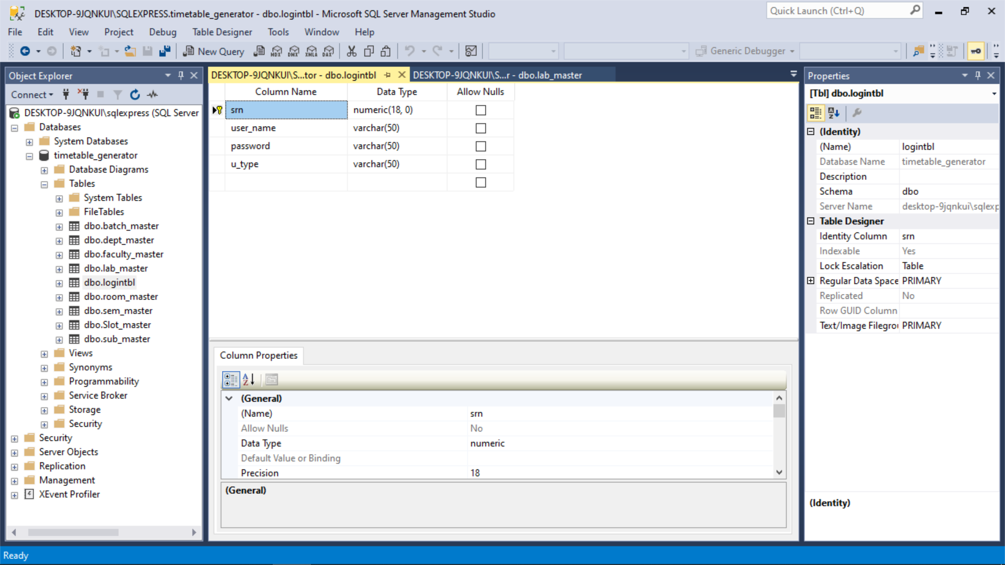

**Department :- Department details comes in this table.**

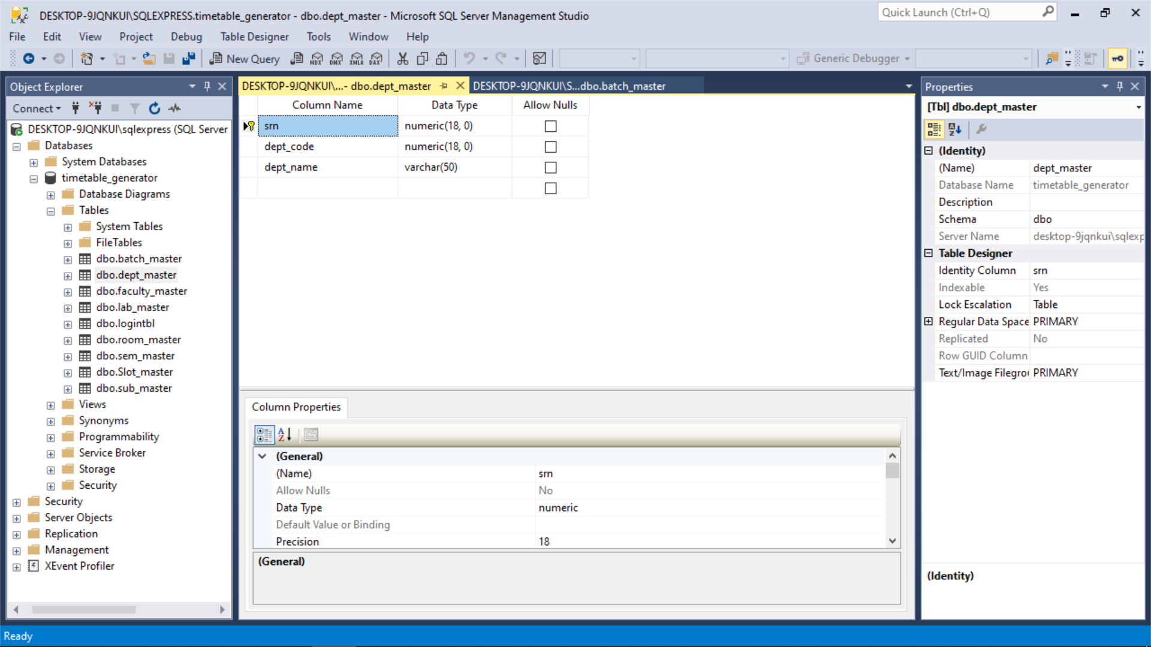

**Semester :- Semester details comes in this table.**

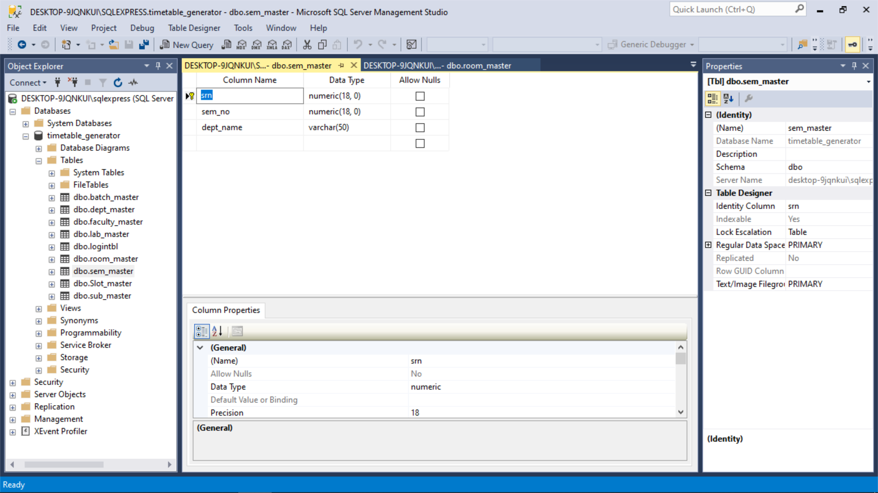

**Subject :- Subject details comes in this table.**

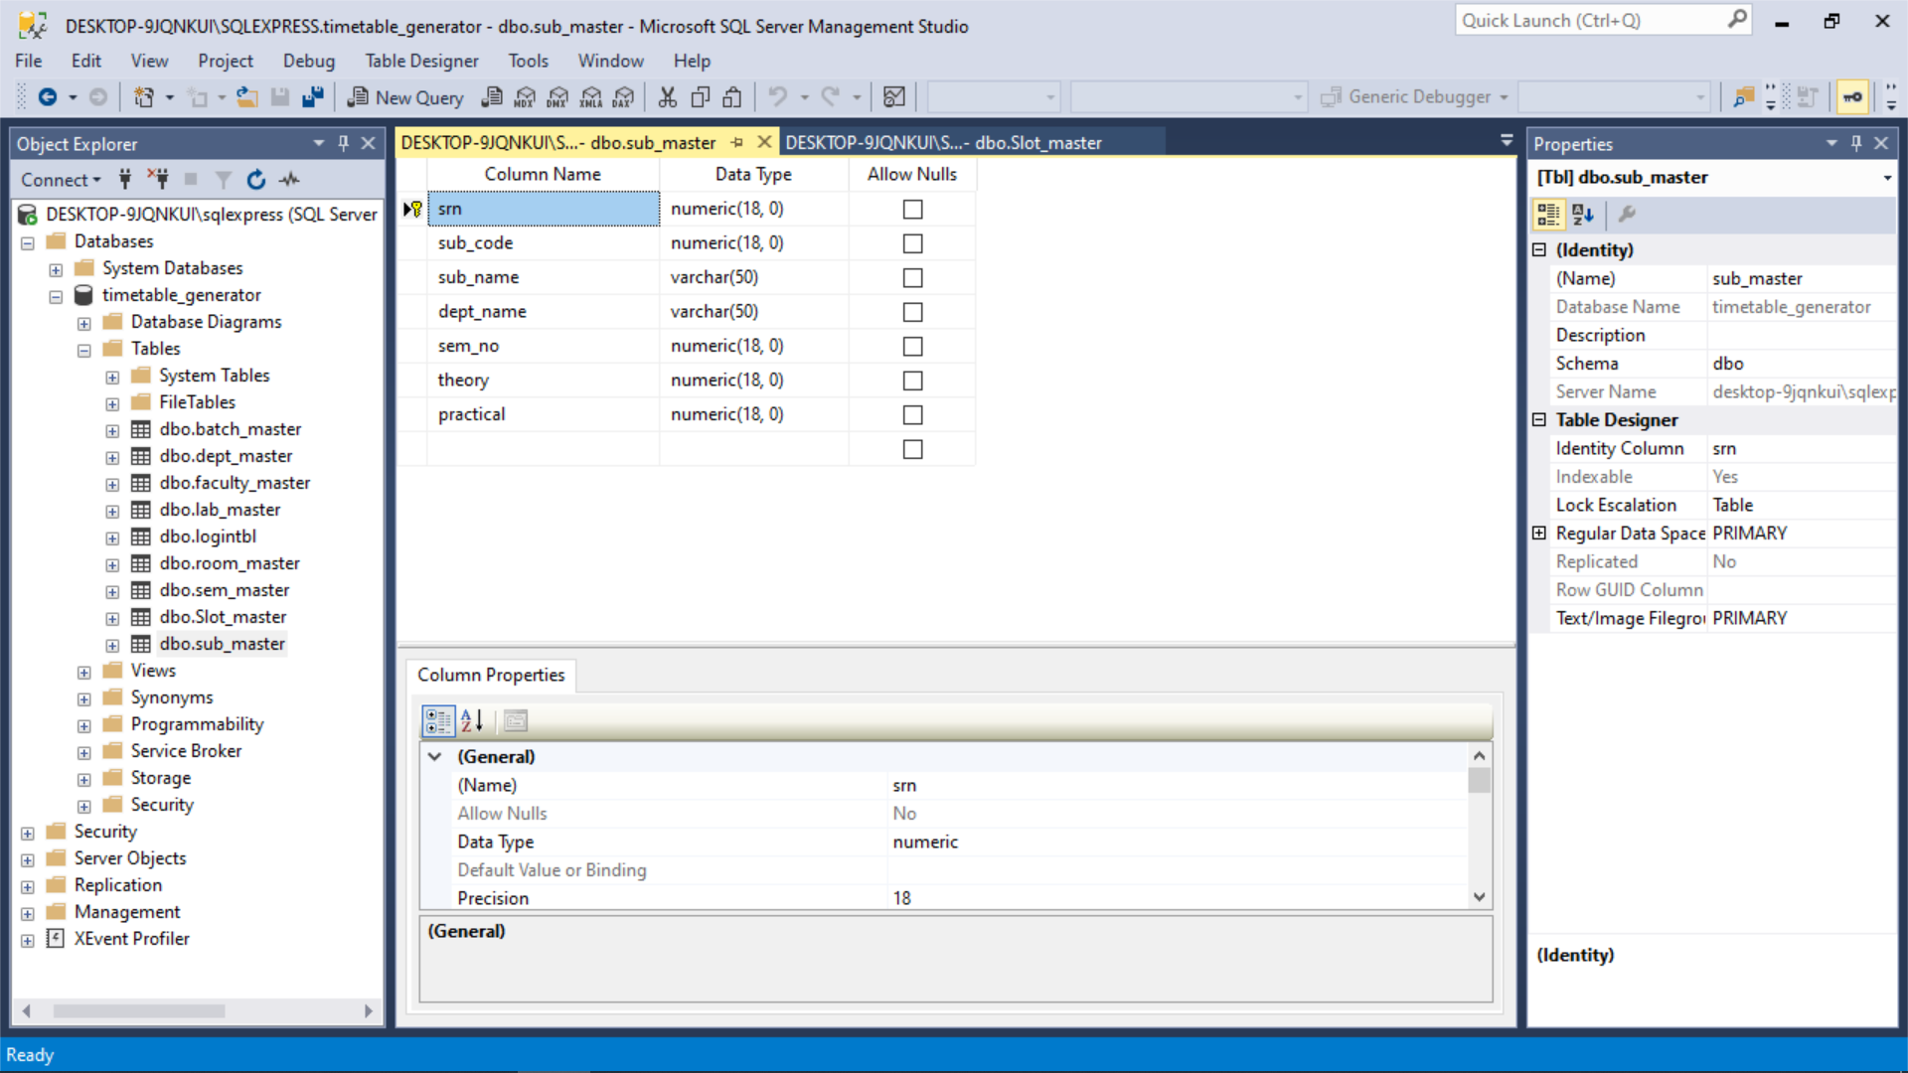

**Lab :- lab details comes in this table.**

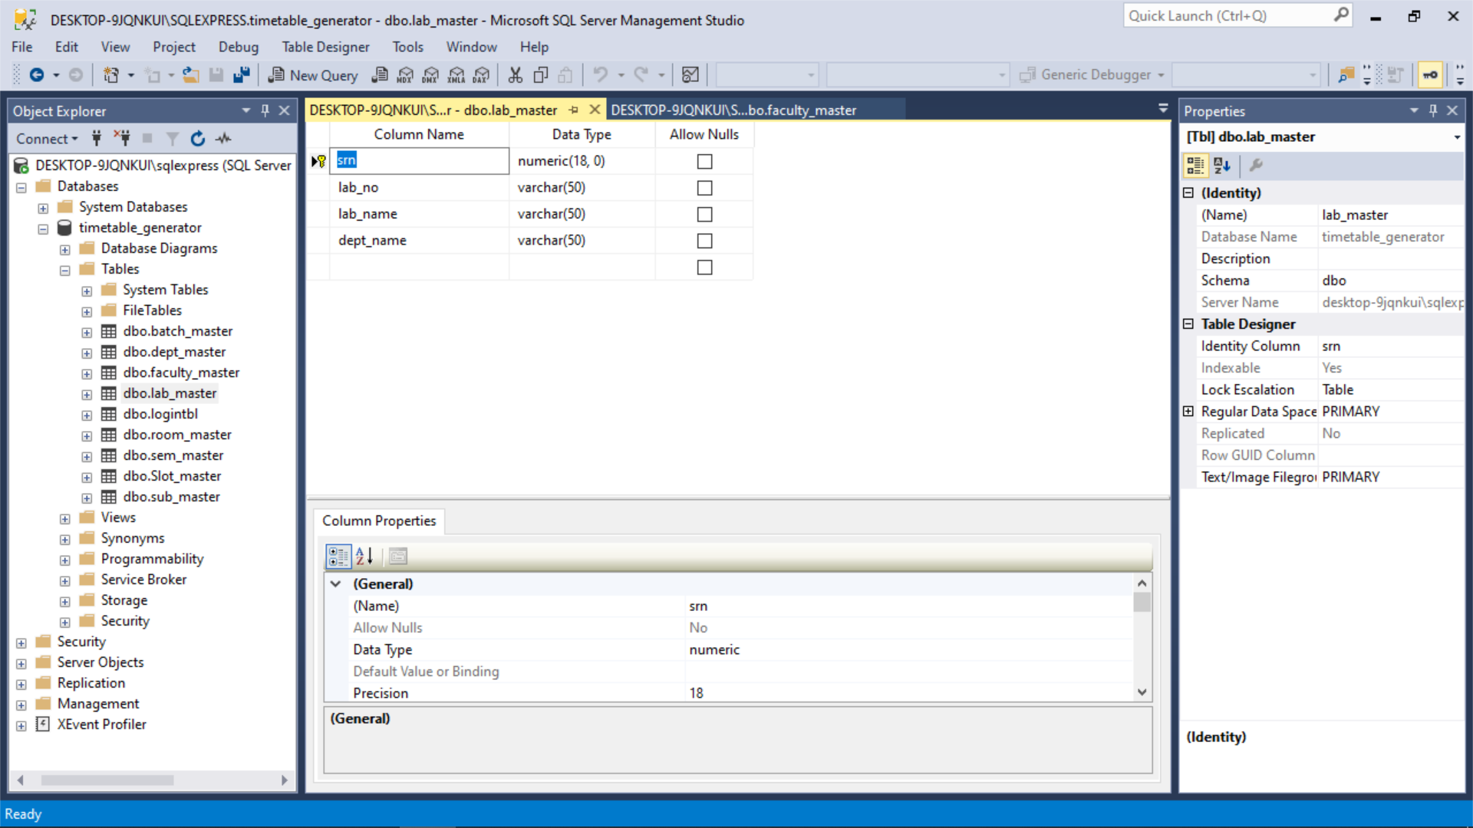

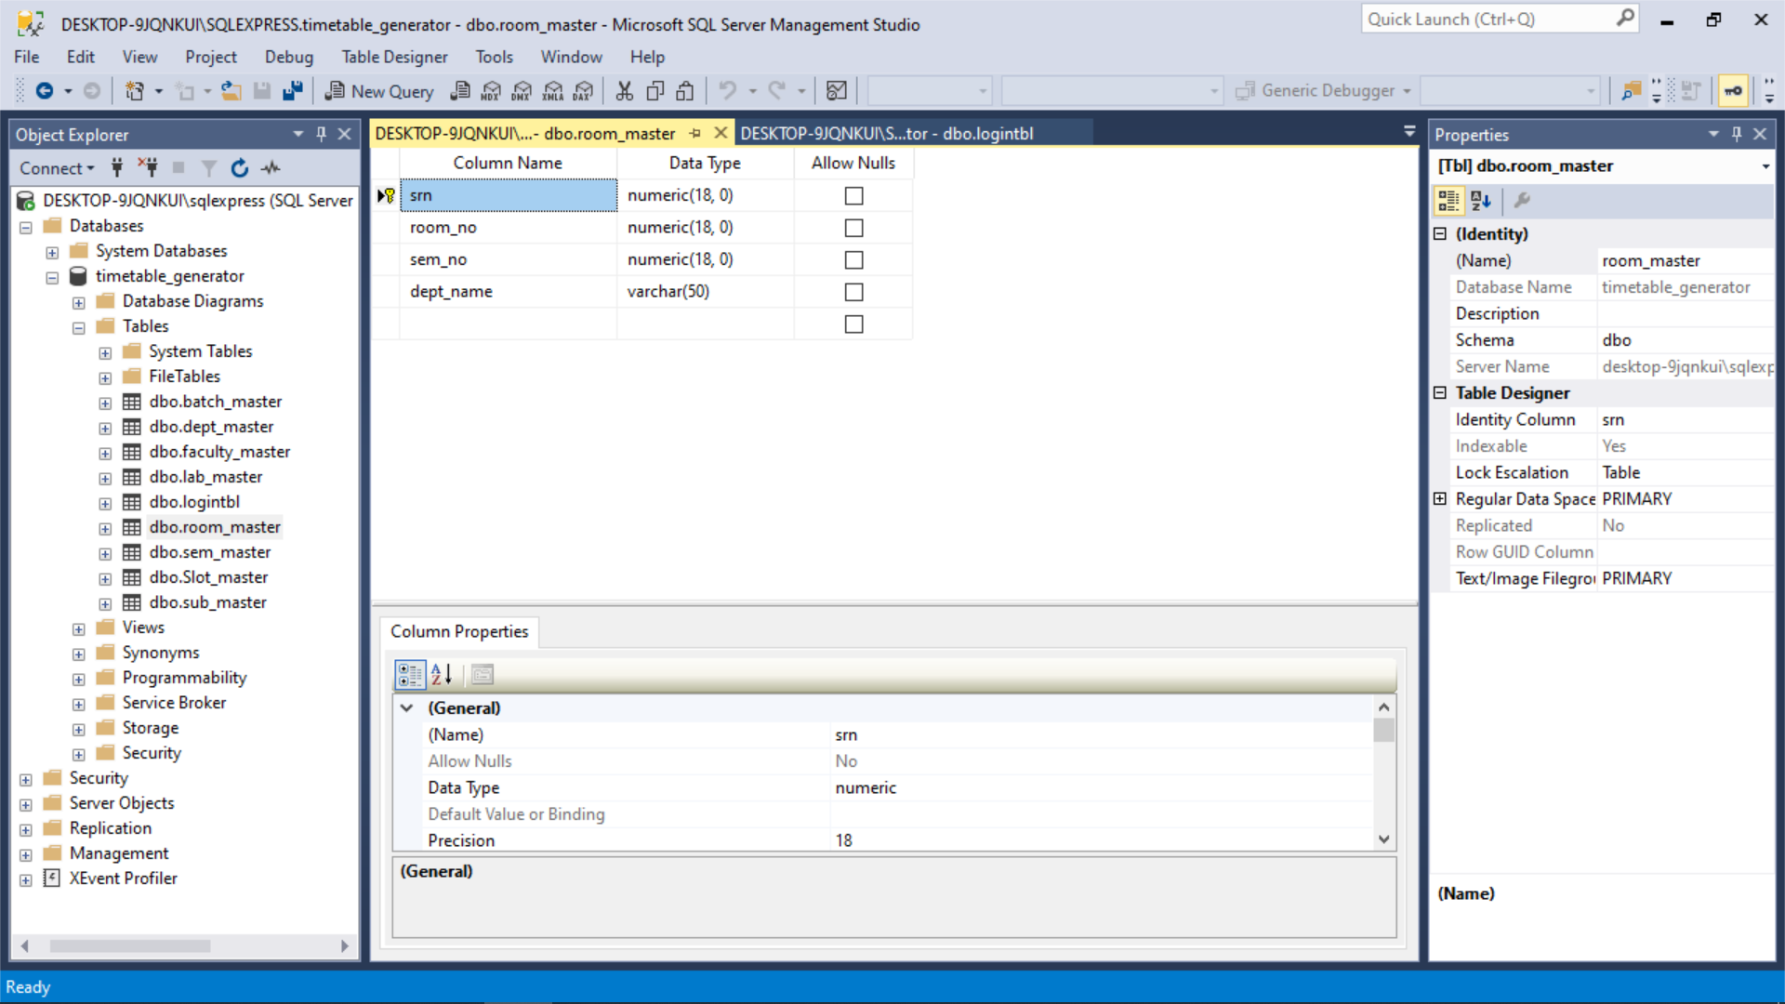**Room :- rooms details comes in this table.**

**Faculty:- faculty details comes in this table.**

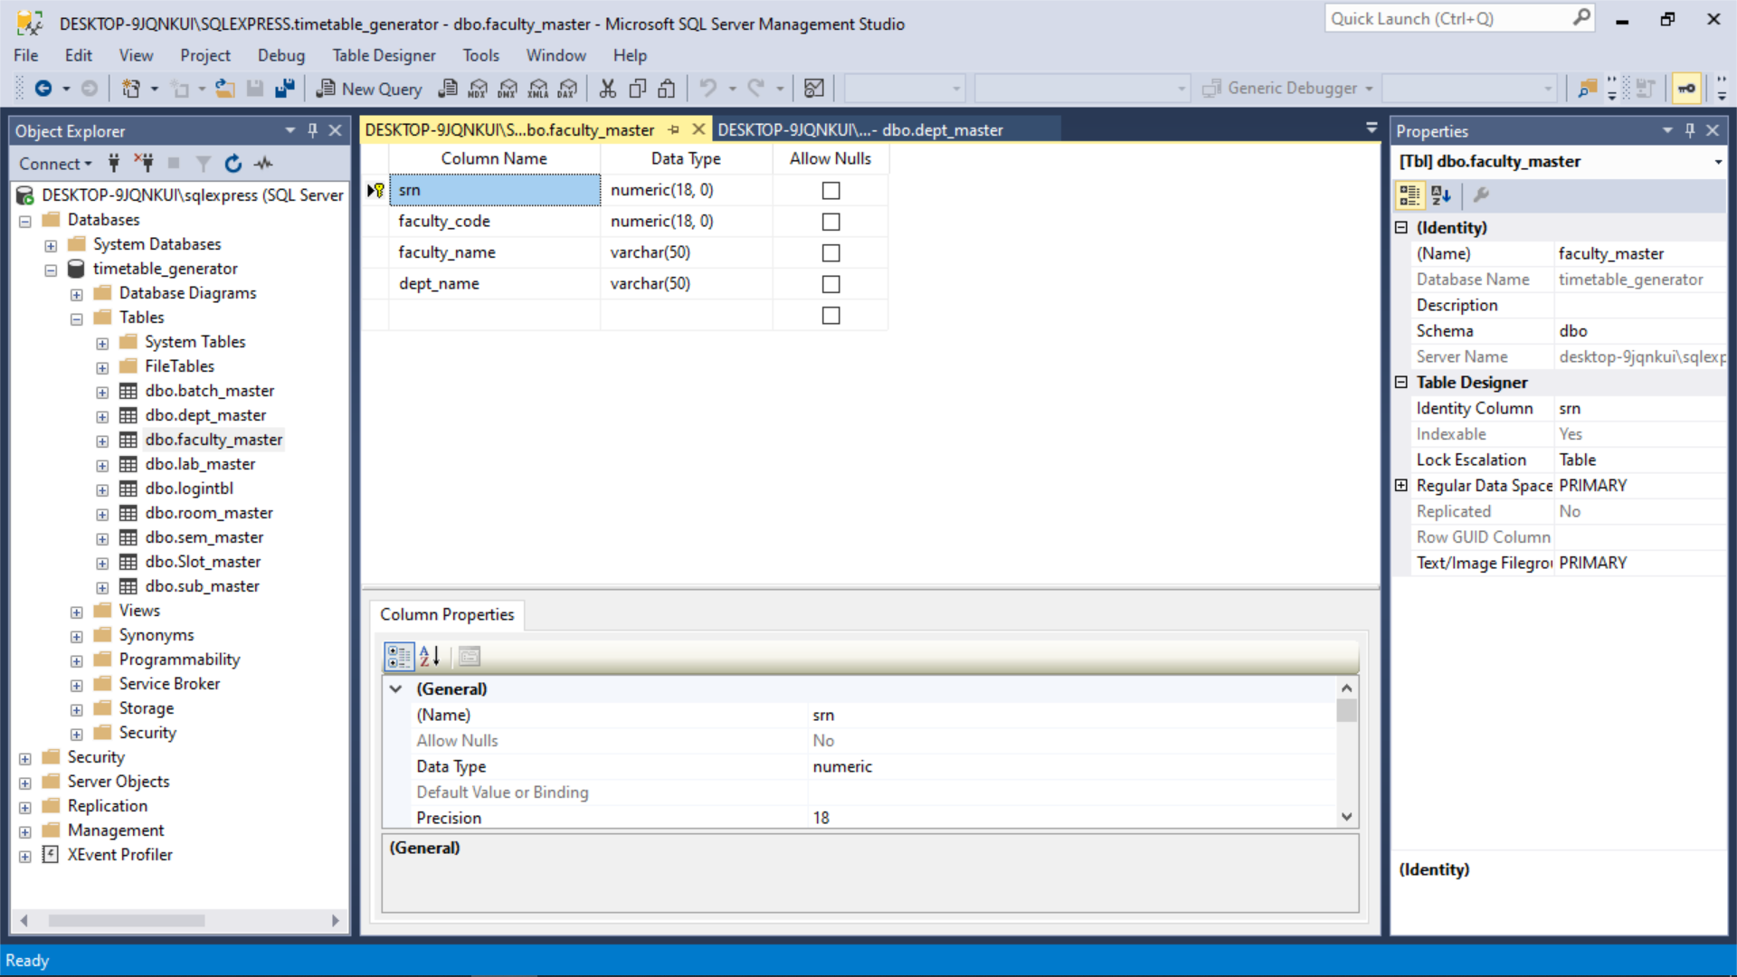

**Batch:- batch details comes in this table.**

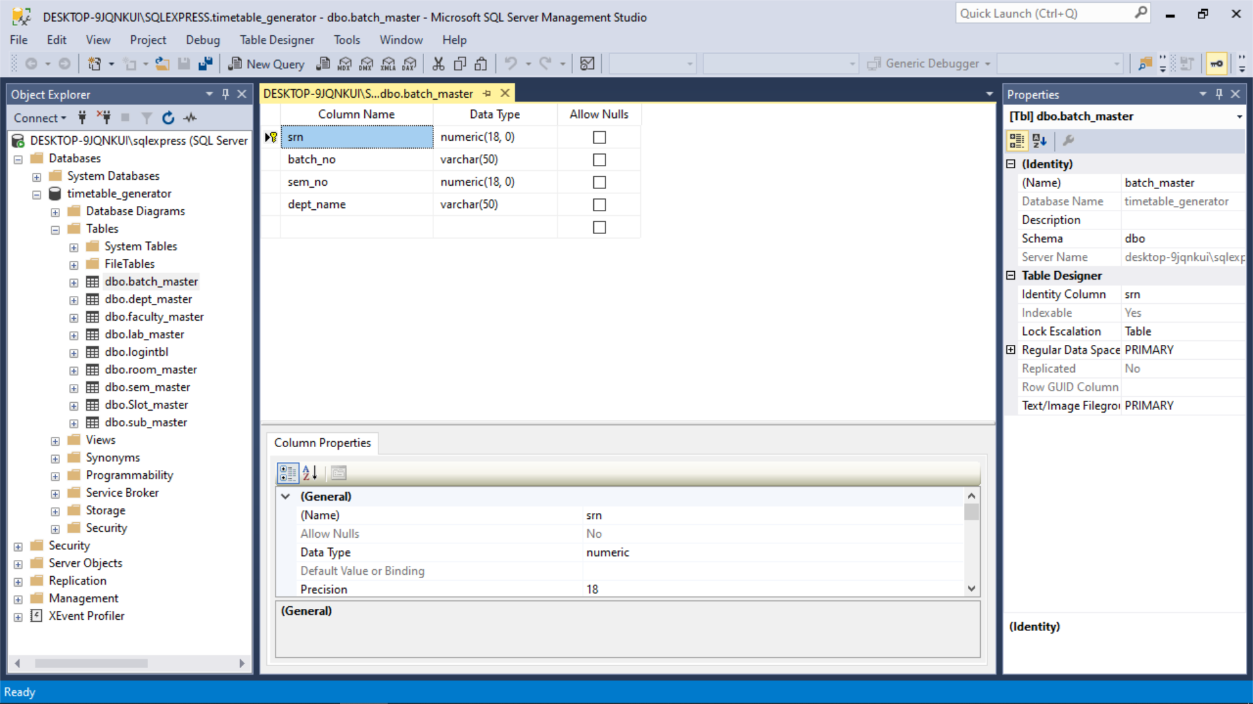

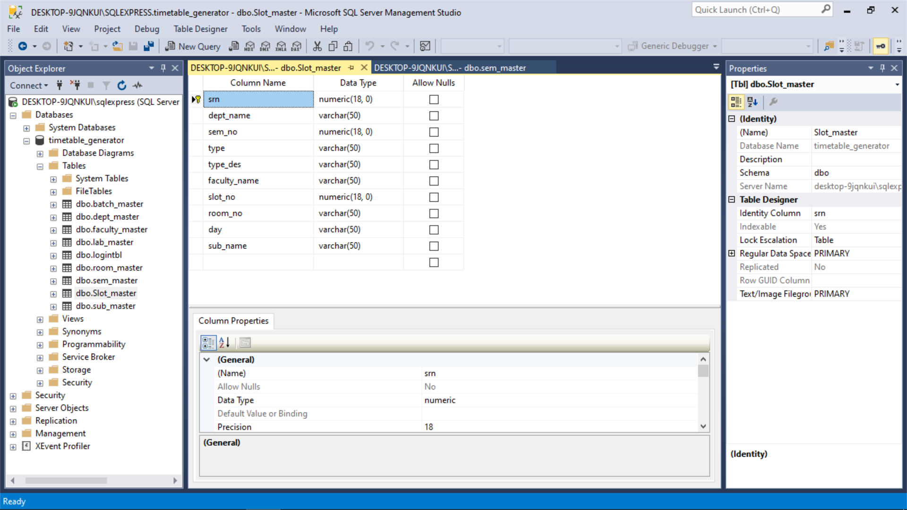**Slot:- All form data entrys comes in this table.**

**Chapter : 5**

**Screen Layout**

**Login Form:- this form is use for login.**

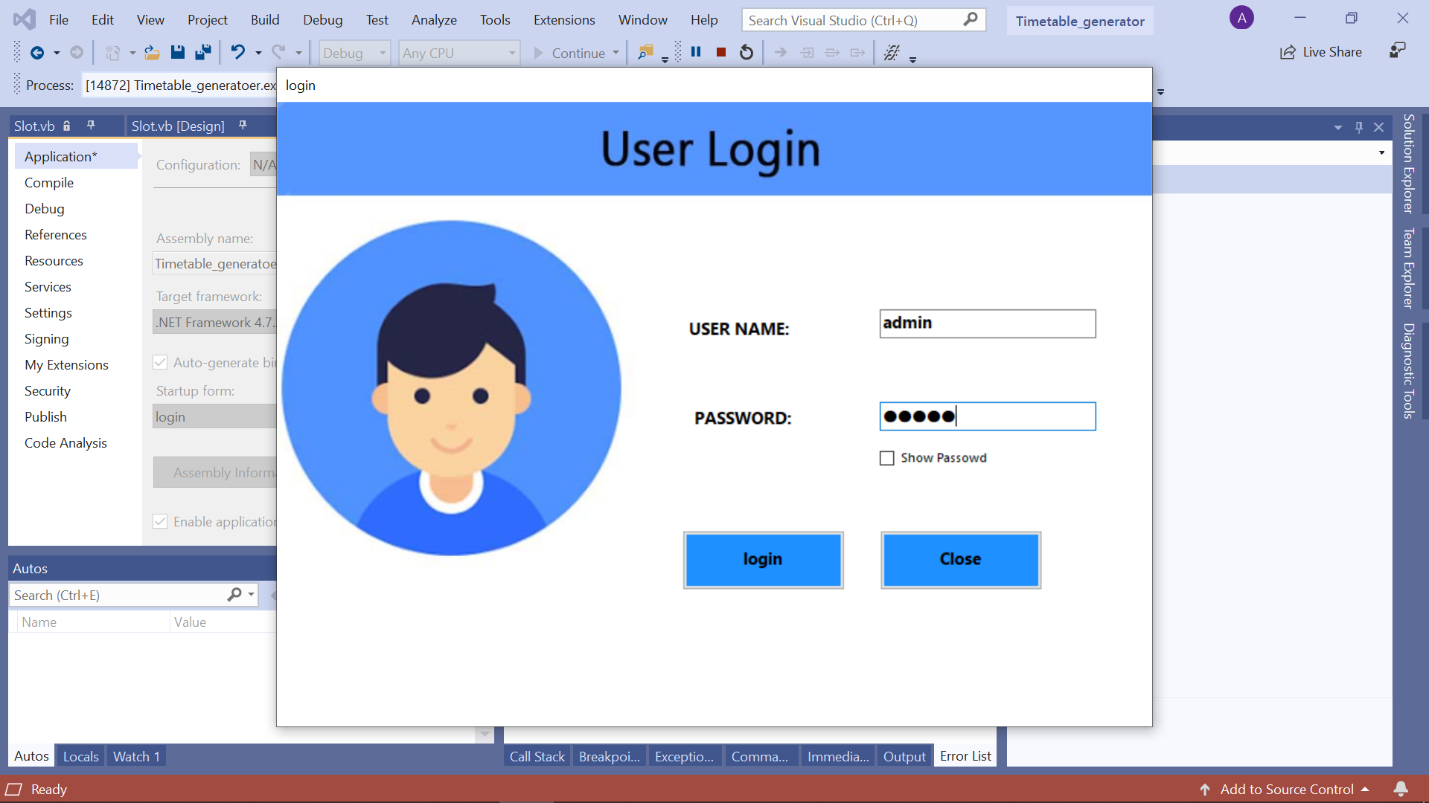

**Main Form:-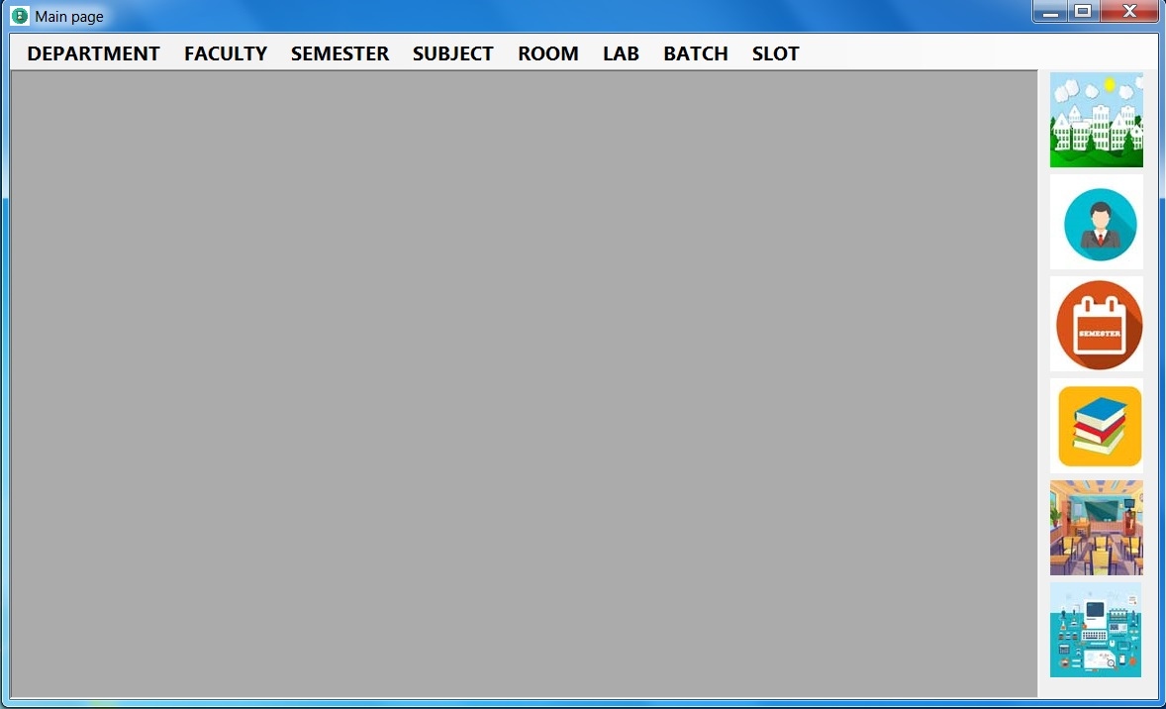 main page where user can enter data.**

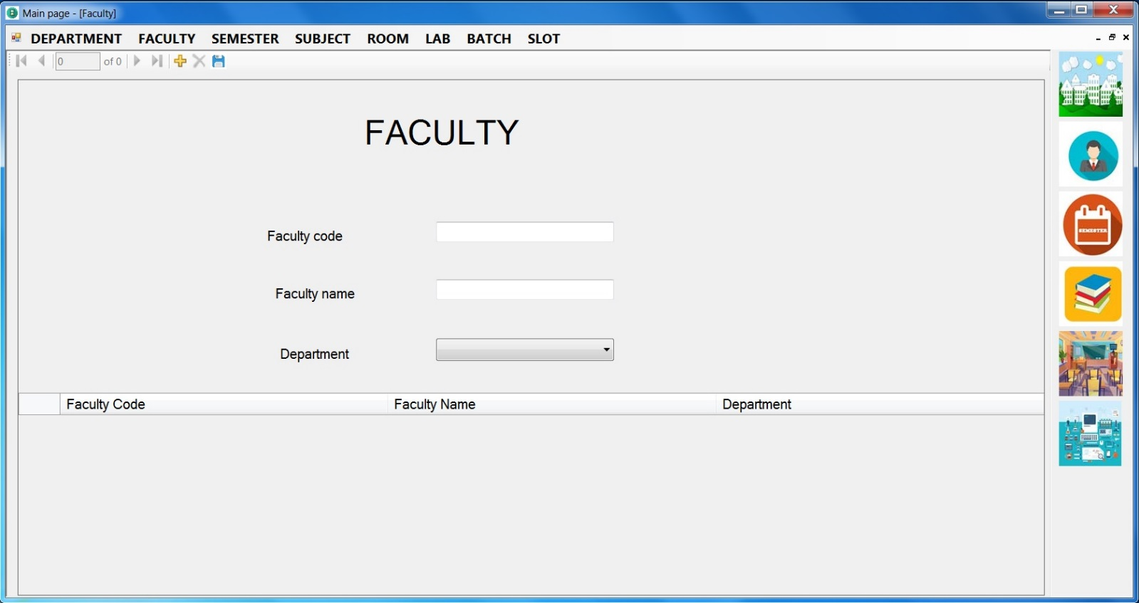**Faculty Form :- this form is use for faculty entry.**

**Department From :- this form is use for Departments entry.**

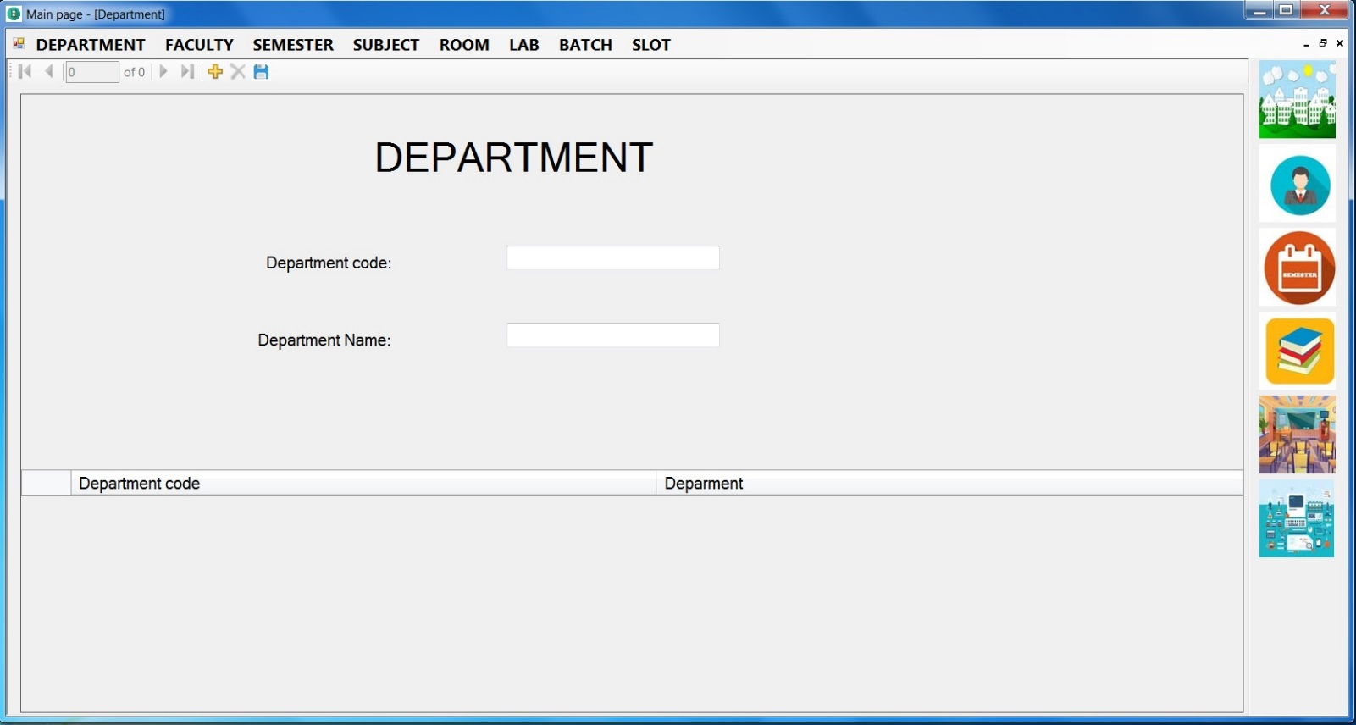

**Semester Form :- this form is use for semester entry.**

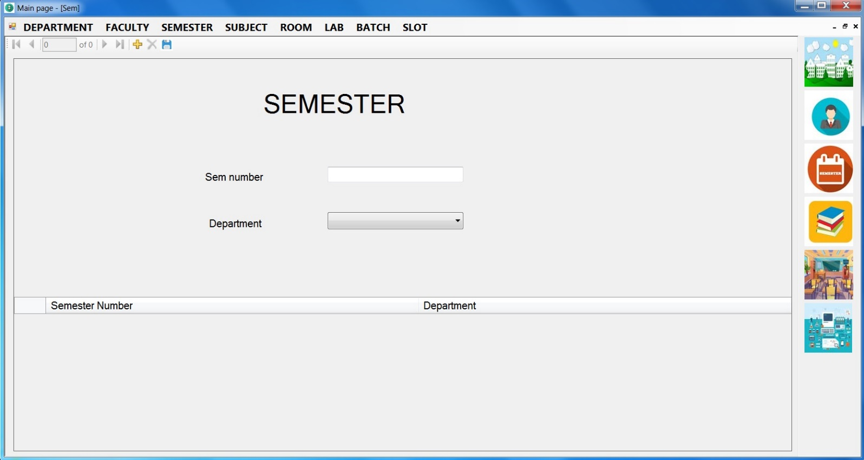

**Subject Form :- this form is use for Subjects entry.**

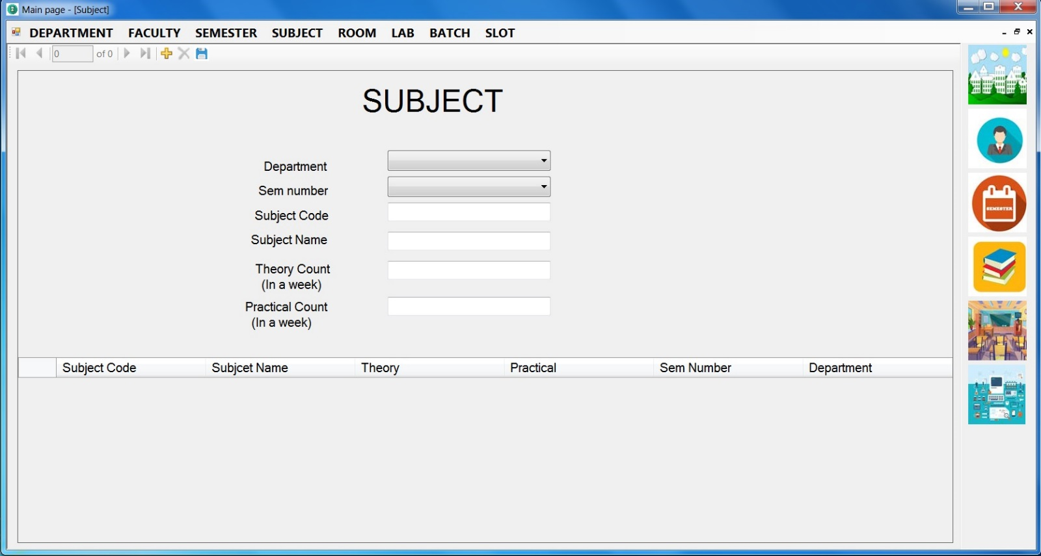

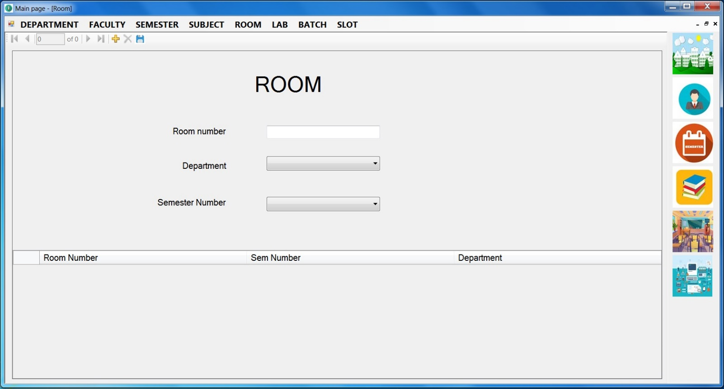**Room Form :- this form is use for rooms entry.**

**Lab Form :- this form is use for labs entry.**

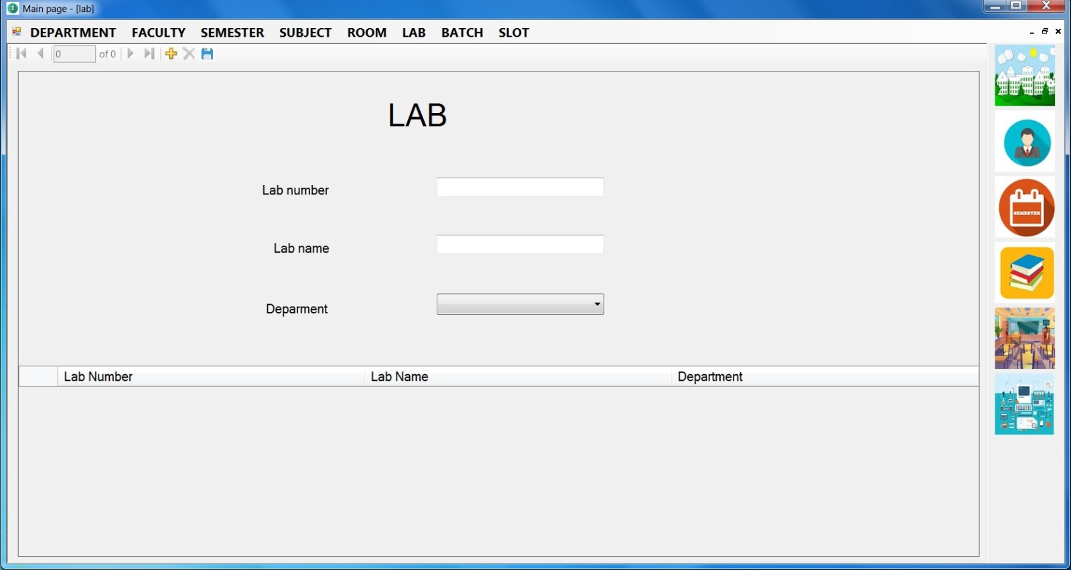

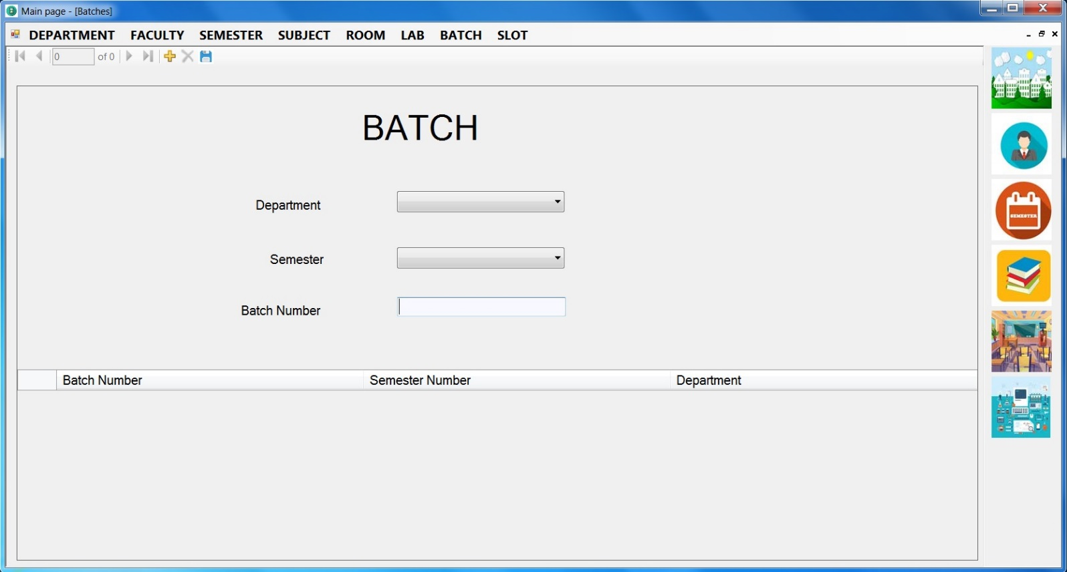**Batch Form :- this form is use for Batches entry.**

**Slot Form :- All forms entry comes in this from and then generate timetable.**

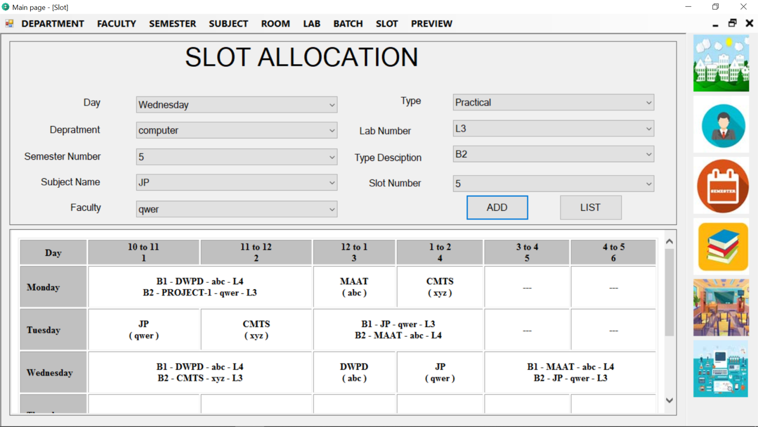

**Chapter : 6**

**CONCLUSION**

**AND**

**LIMITATION**

**6.1** **Conclusion:**

The Timetable Management System Windows-Application Has been successfully completed by the developer within the scheduled time and all the function requirement of the project that Were set in SRS have been fully achieved. The external interface requirement and input/output formats have been implemented as Per the requirement specifications.

**6.2 Limitation:**

* Security policy is dependent on password protection.

**6.3 Future scope of the Project:**

* In future we can comeover the Limitations of the project.
* The Timetable can be shared on mails.
* We can update the security Policy and can provide higher Security.

